**INFO 7374 DIGITAL MARKETING ANALYTICS**

**Assignment – 2**

**Spotify Project Proposal**

**Team 9 :**

**Ankita Moharir**

**Suhas Balanagar**

**Ankita Brahmankar**

**ABOUT SPOTIFY**

Spotify is a music-service provider with additional features like improved streaming qualities**.**

**PROOF OF CONCEPT**

Spotify has recently launched a new product called FLAC (Free Lossless Audio Codec) audio streaming in the market. Spotify wants to improve the audio quality and understand the customer response to the newly launched product based on previous campaigns and promotions. Based on customer feedback on our newly launched product, analysts of Spotify will analyze the reviews and comments from different platforms and determine the sentiment of the customers from different states about the product, further expanding the market.

**Architecture**

Market Sizing

Data exploration

Sentiment Analysis

Marketing Strategies

Customer Review and comments data

**DATA EXPLORATION**

Data exploration is an initial step in data analysis where an analyst makes use of visual exploration to understand what needs to be done with the dataset. We incorporate EDA(Exploratory data analysis) strategies that summarize or otherwise reveal features of interest within a dataset which are not likely visible through traditional [close reading](https://en.wikipedia.org/wiki/Close_reading).

We will Analyze the data by generating simple statistics such as word frequencies over the different customer reviews and plotting word clouds as well. We will perform EDA on the demographics, customer and revenue data to further determine the size of our market.

**SENTIMENT ANALYSIS**

Sentiment analysis seeks to quantify the emotional intensity of words and phrases within a text.  We will be doing basic text processing methods such as tokenization, stop word removal, stemming and vectorizing text via term frequencies (TF) as well as the inverse document frequencies (TF-IDF). Along with this we will determine the sentiment related to the review of the customer. We will use the Plot.ly library to make interactive graphs for sentiment analysis.

**MARKET SIZING**

Market sizing is the process of estimating the potential of a market. The major metric used in determining the size of the market is known as TAM(Total Addressable market)

**TAM** - The potential sales value of a specific target segment over a specified time frame that takes into consideration the available demand for a particular service or product.

***How is it calculated?***

* TAM = (# of Opportunities) x (% Targetable Opportunities) x (Average Selling Price of Opportunities)
* Targetable opportunities can be estimated via a market research survey or an assessment of current market penetration.
* It is better to determine it on bases of segments (i.e states in our model) instead of calculating the overall market

***Important Assumptions:***

* We have to assume that the company can win 100% of its targetable opportunities.
* Price is consistent across all segments and customers.

***Costs & Benefits:***

• Provides more realistic picture of market opportunity than total market potential.

• Always overstated

**Bottom-Up Analysis:**

While Top-Down market sizing is usually easy to do, it can be misleading as the largest possible size estimate is considered and there is a possibility to over-estimate the TAM. Hence, we are not sure if we can really reach the entire market using Top-Down Analysis.

Therefore Bottom-Up market sizing gives us a clear picture of those factors. To do a bottom-up analysis you start with the basic units of your business (your product, price, customers) and estimate how large you can scale those units. 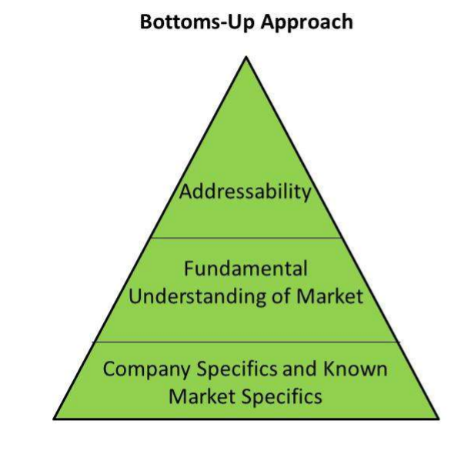

**Platforms**

* **Jupyter notebook** – Data exploration and Sentiment Analysis python scripting
* **Tableau** – To create dashboards and visualize the results of the sentiment analysis and to give the marketing strategies.